Project Approach Overview
The Proposer must provide a narrative overview of how the proposed solution will meet the requirements for the products and services sought through this procurement. For each question, provide a one (1) to two (2) page essay along with any relevant user manual and/or reports.
Describe the Proposer’s proposed approach to meeting the requirements for each component, either by leveraging existing products, configuration, through customization, development, or a combination.
Responses in this section must be highly focused on the City-specific business processes and requirements and not simply provide generic or marketing descriptions of solution capabilities.

General
Instructions: For each of the below shared functional areas, provide a narrative description of how the Proposer will address each area.

General System Overview
Provide information of your current cashiering system’s general workflow which includes:
- Current hardware supported and a description of the current POS devices supported
- Description of cashier operator interface including significant features of the software
- Detailed workflow of end of day closing including samples of reports used for balancing and auditing
- Existing interfaces with financial institutions including remote deposit solutions

Security and Fraud Protection Requirements
Describe how your company with the following application security- and fraud-related requirements:
- PCI Compliance Level 1; please provide the most recent audit results
- Encryption methods to include, at minimum, support for tokenization of payment and secure methods of decryption to ensure that all customer data is portable and available to CCSF in the event that the relationship between the vendor and CCSF is concluded after live customer transactions have been processed
- Audit trails for all actions taken on the account, including but not limited to routing changes, fee changes, permissions changes, user management changes and any relevant actions for all enabled products and features.

Integrations
Describe any existing enterprise integrations you currently support, e.g., ERP systems, EDMS systems, or centralized unified commerce platforms. Diagrams of current environments are strongly encouraged.

Project Approach
Please submit a Project Approach describing the City’s intent and objectives and Respondent’s approach to achieving those objectives. This project approach must respond to the questions and cashiering use cases presented below:

Permit Center Cashiering Use Cases
The City is consolidating the existing permitting departments from multiple locations across the city into a Permit Center that includes more than 11 different permitting departments into one floor at one location at a new building at 49 South Van Ness. The Permit Center will serve as a single location for construction, special events and business permitting. Departments housed at the future Permit Center include Building Inspection, Planning, Public Works, Environmental Health, and the Fire Department, among others. Routine transactions range from information inquiries, over-the-counter permit approvals, and application submittals for multi-agency review. Every tenant department in 49 South Van Ness is expected to leverage the centralized cashiering functionality.
A primary goal of the Permit Center is to create a fluid and user-friendly user experience which limits “bouncing” between desks and stations as users move through the permitting process. In many cases, the cashiering process step is not the final step in the user experience, but rather a dependency required to move on to the next step or obtain an item (e.g. permit, license). The cashiering solution must be able to handle both the number of departments, their systems and the complexity of various processes whilst still delivering an accessible user experience.

How can your cashiering solution help the City optimize user experience and create a seamless user experience while also supporting money handling best practices across multiple systems?

The Permit Center is a new concept for the City and County of San Francisco. As with all new concepts, the functionality and design of the Permit Center are both continuously evolving. The requirements for the Permit Center may change once the Permit Center is open and departments are co-existing in the same space.

How does your implementation methodology support cycles of continuous improvement?

The Permit Center service model is still in development. However, one scenario for cashiering involves having the largest tenant, the Department of Building Inspection, maintain a cashiering installation system separate from other tenants of the Permit Center. The remaining tenants, the rest of the 11 or so departments, would use a single centralized cashiering system.

How would you architect a solution to support this use?

A vision of the Permit Center is to provide improved services for constituents by streamlining processes or creating SOA that connects processes. A key to doing this to find a relationship between each department’s host system.
Every business in San Francisco must register with TTX and obtain a Business Account Number (“BAN”) which serves as a unique identifier with TTX as well as several other agencies for the lifetime of their operation. The BAN enables the agencies to share data easily.
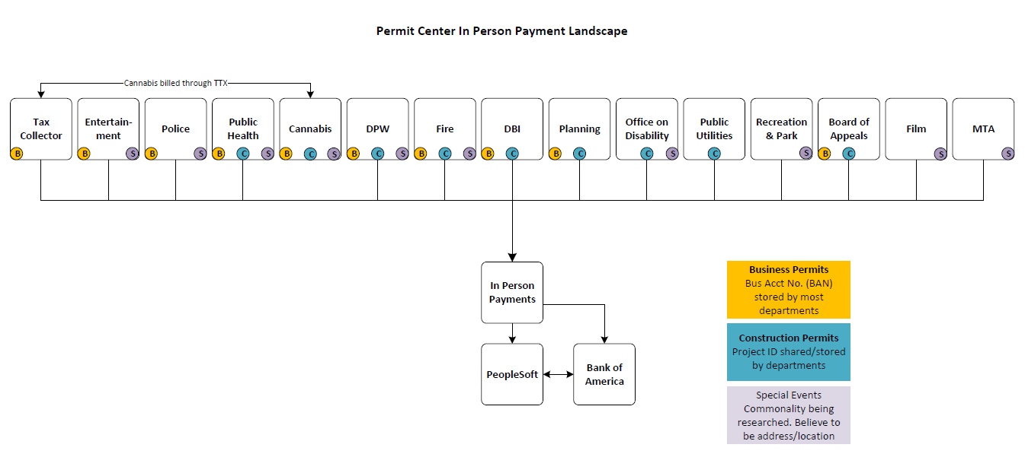
CCSF is looking for a vendor who can consolidate on a common data attribute like the BAN and aggregate transactions so the user experience is blind the various host systems.

Does your system have functionality to consolidate transactions or is it capable of building such functionality in the future?

TTX Cashiering Use Cases
The current cashiering installation collects 30 different payment types that settle into 15 different host systems. The system integrates with Image RPS from Deluxe Financial which aggregates data from all payment channels for the end-of-the-day deposit.
In addition, Deluxe Financial solution includes a Hyland OnBase installation which acts as an archive and repository for all check images and financial transactions. Data is aggregated from all sources and serves as the system of record for financial transactions (e.g. deposited dollars, payment reversals and transfers in the general ledger).
To improve performance and create greater flexibility, TTX is willing to uncouple its cashiering solution from the Deluxe Financial engine if the following can be achieved:
- Continuation of remote deposit functionality with Image Cash Letter services to Bank of America
- Continuation of the integration with PeopleSoft 9.0 Account Receivable module which posts collections directly to the CCSF general ledger
- Continuation of the integration with Hyland OnBase for all financial transactions and payment archivals in a format that can be consumed by the current financial reporting and archiving module
The dimensions and specifications of TTX’s cashiering stations are as follows:
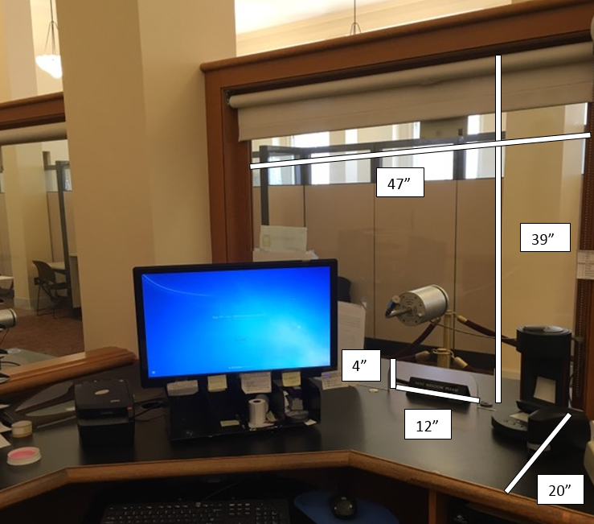

How would you propose architecting a solution that supports the above?

Technical

Architecture
Based on the information contained in this document and the functionality identified in Template D, please provide a general description of your proposed solution, including the following:
- Description of the solution architecture. System environment is comprised of a development, test and production environment and disaster recovery which may or may not be managed and hosted by the Contractor and used by the City for supporting the system
- Diagram(s) of the solution architecture, including integration with the City’s Active Directory or Oracle Identity and Access Management System for user identity management using SAML and implement the connection.

- Diagram(s) of the implementation architecture (that is, where the components of the solution can be implemented and integrated).
- Description of technology deployment options (Hosted or On-Premise)
- Provide an API environment for the system to integrate seamlessly with: Accela Land Management; Aumentum; Salesforce; Screendoor and proprietary software

Product Support
Identify the geographic locations of available support staff and the levels of support provided for the proposed payment solution and associated products. Include in your response:
- Ability to meet SLA expectation of 99.9% uptime
- How the SLAs are measured (for example, API availability, API latency, manual interface availability and/or page latency)
- Your responsiveness (that is, levels of escalation and the guaranteed response times associated with them)
- Twenty-four-month history of outages and downtime, indicating details of scheduled vs. unscheduled, duration, impact and resolution (if applicable)
- Standard notification timeframe window prior to maintenance and/or downtime
- Indicate the penalties you will incur if the SLAs and guaranteed responsiveness levels are not met (for example, service credits and refunds).

Disaster Recovery
Describe your redundancy and disaster recovery capabilities

Technical Environments
Describe the different technical environments supported for development and testing. Provide your standard operating process for migrating between environments

Upgrades and New Versions
The City requires that all software products and pricing reflect the current and latest release of the software stack and systems. For example, if the software operates on a Microsoft product it must be a current version.
Describe:
- The software stack’s release date and plans for upgrade to new release
- The process for new version releases and the application of service packs to the payment solution product(s)
- The average timeframe between release of new platform products and your products’ certification on the new release
- The quality assurance/testing processes to follow to determine whether an upgrade or custom modification is suitable for release
- The process by which opportunities for system enhancements are identified, screened, programmed, field-tested and released to customers
- Whether the upgrade methodology includes a tracking system not only to report on the status of an upgrade, but also to record problems and bugs

Training
Describe the training approach to enable CCSF staff to fully operate and support the proposed solution.

R&D
Describe your research and development (R&D) philosophy, including the percentage of revenue that you have invested in R&D for the past three years and the percentage of revenue expected to be invested in R&D next year.

Other Information
Include any additional information that you feel would help the City evaluate your submission.

